CS 255 Module Six Assignment: UML Diagram Analysis and Improvement
Diagram Interpretation
The UML activity and sequence diagrams describe the process of a customer using an ATM to withdraw cash. The activity diagram focuses on the steps involved in the transaction, such as verifying the PIN, selecting a withdrawal amount, dispensing cash, and printing a receipt. The sequence diagram shows how the user, ATM, and bank interact during the same process. Information passed between them includes the user’s PIN, the bank’s response confirming whether the PIN is valid, the requested withdrawal amount, and the ATM’s response to the user. Together, the diagrams show both the overall workflow and the communication that takes place between the different parts of the system.
Design Analysis
One deficiency in the original design is the way an incorrect PIN is handled. In the activity diagram, entering the wrong PIN immediately causes the transaction to end. This could be improved by allowing the user a limited number of attempts to enter the correct PIN before terminating the transaction. For example, the ATM could allow three attempts and display an error message after each incorrect entry. This would make the process more realistic while still maintaining account security.
Another issue is that the original design does not show the bank authorizing the withdrawal before cash is dispensed. The ATM asks the user for an amount and then moves directly toward dispensing the cash. A better design would send the withdrawal request to the bank and wait for approval. If the bank denies the request because of insufficient funds or another restriction, the ATM should display the reason and allow the user to choose another action.
The original diagrams also leave out some steps that would normally be part of an ATM transaction. For example, the card is never shown being returned to the user, and the sequence diagram does not include the receipt process shown in the activity diagram. Adding these steps makes the transaction flow more complete and makes the different views of the system more consistent.

Reconstructed UML Activity Diagram
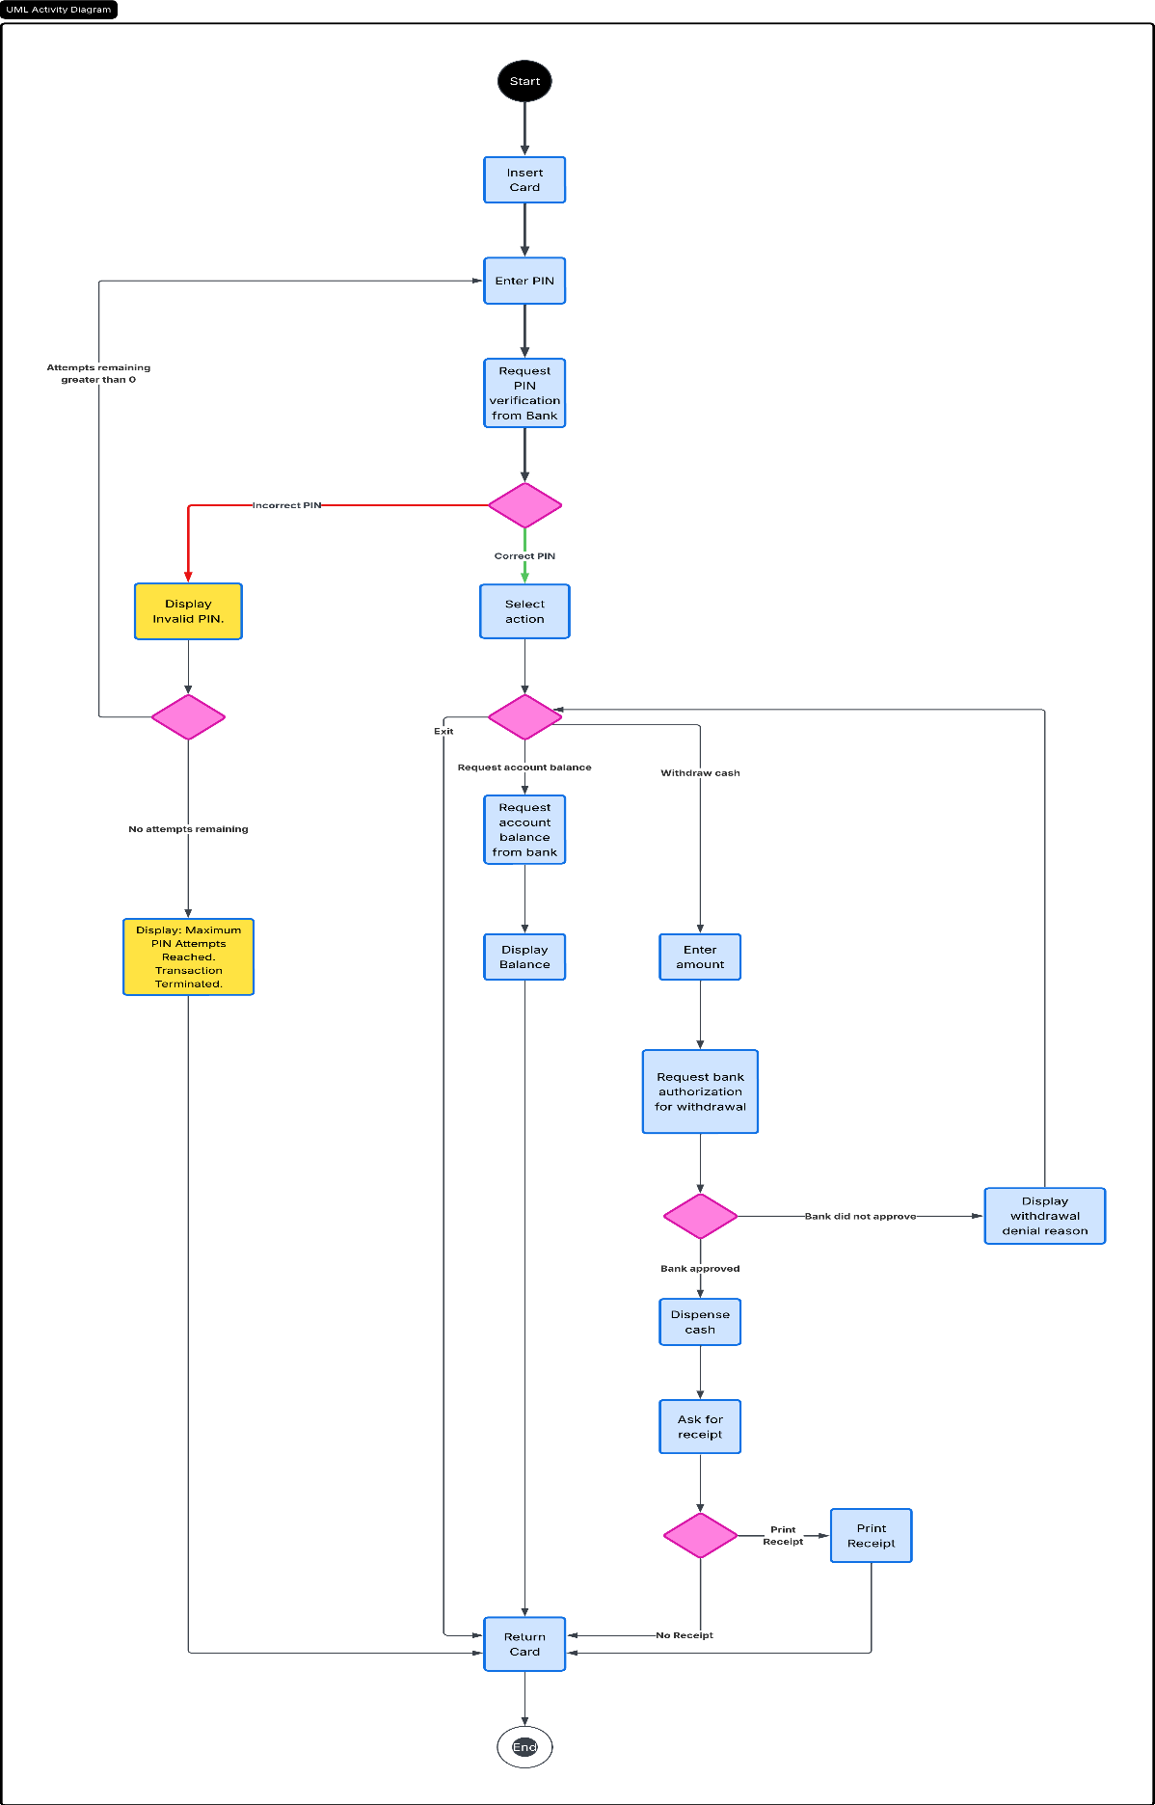
Improvements Introduced in the Reconstructed Diagram
The reconstructed activity diagram expands the original ATM process by adding several paths that were previously missing. The ATM now requests PIN verification from the bank and allows the user multiple attempts if the PIN is incorrect. After three unsuccessful attempts, the transaction is terminated and the card is returned. Once the PIN is accepted, the user can choose to request their account balance, withdraw cash, or exit. Balance information is requested from the bank, while withdrawal requests must receive bank authorization before cash is dispensed. If the withdrawal is denied, the ATM displays the reason and returns the user to the action selection. The updated diagram also includes the option to print a receipt and ensures the card is returned before the transaction ends.

